operon model?
- Monod and Jacob proposed the operon model in 1961to explain how the lac system is regulatedThe term operon refers to two or more contiguous genes and the genetic elements that regulate their transcription in a coordinate fashionPromoters had not yet been discovered when Monod & Jacob proposed the operon model but were readily incorporated into the operon model after their discovery.
- The five major featurs of the model are:-
- 1. The products of the lacZ, lacYand lacAgenes are encoded in a single polycistroniclac mRNA molecule.
- 2. The promoter for this mRNA molecule is immediately adjacent to the lac region.
- Promoter mutations (p-) that are completely incapable of making β-galactosidase, permease, and transacetylase have been isolated. The promoter is located between lacI and lacO.
- 3. The operator is a sequence of bases (in the DNA) to which the repressor protein binds.
- 4. When the repressor protein is bound to the operator, lac mRNA transcription can’t take place.
- 5. Inducers stimulate lac mRNA synthesis by binding to the repressor. This binding alters the repressor’s conformation so it can’t bind to the operator. In the presence of an inducer, therefore,
- The operator is unoccupied and the promoter is available for initiation of mRNA synthesis. This state is called derepression.
- This simple model explains many of the features of the lac system and of other negatively regulated genetic systems.
- However, lac operon is also subjected to positive regulation.
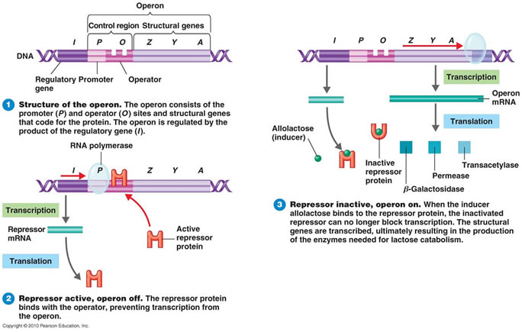

7: RNA editingexplain?
RNA editing is a molecular process through which some cells can make discrete changes to specific nucleotide sequences within a RNA molecule after it has been generated by RNA polymerase. RNA editing is relatively rare, and common forms of RNA processing (e.g. splicing, 5'-capping and 3'-polyadenylation) are not usually included as editing. Editing events may include the insertion, deletion, and base substitution of nucleotides within the edited RNA molecule.
RNA editing has been observed in some tRNA, rRNA, mRNA or miRNA molecules of eukaryotes and their viruses, archaea and prokaryotes.^{[1]} RNA editing occurs in the cell nucleus and cytosol, as well as within mitochondria and plastids. In vertebrates, editing is rare and usually consists of a small number of changes to the sequence of affected molecules. In other organisms, extensive editing (pan-editing) can occur; in some cases the majority of nucleotides in a mRNA sequence may result from editing.
RNA-editing processes show great molecular diversity, and some appear to be evolutionarily recent achievements that arose independently. The diversity of RNA editing phenomena includes nucleobase modifications such as cytidine (C) to uridine (U) and adenosine (A) to inosine (I) deaminations, as well as non-templated nucleotide additions and insertions. RNA editing in mRNAs effectively alters the amino acid sequence of the encoded protein so that it differs from that predicted by the genomic DNA sequenc

Editing by insertion or deletion
RNA editing through the addition and deletion of uracil has been found in kinetoplasts from the mitochondria of Trypanosomabrucei^{[3]} Because this may involve a large fraction of the sites in a gene, it is sometimes called "pan-editing" to distinguish it from topical editing of one or a few sites.
Pan-editing starts with the base-pairing of the unedited primary transcript with a guide RNA (gRNA), which contains complementary sequences to the regions around the insertion/deletion points. The newly formed double-stranded region is then enveloped by an editosome, a large multi-protein complex that catalyzes the editing.^{[4][5]} The editosome opens the transcript at the first mismatched nucleotide and starts inserting uridines. The inserted uridines will base-pair with the guide RNA, and insertion will continue as long as A or G is present in the guide RNA and will stop when a C or U is encountered.^{[6][7]} The inserted nucleotides cause a frameshift and result in a translated protein that differs from its gene.
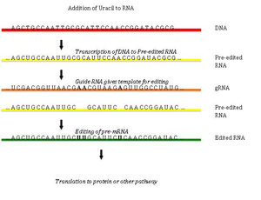
The Effect of Uracil Insertion in pre-mRNA transcripts
The mechanism of the editosome involves an endonucleolytic cut at the mismatch point between the guide RNA and the unedited transcript. The next step is catalyzed by one of the enzymes in the complex, a terminal U-transferase, which adds Us from UTP at the 3’ end of the mRNA.^{[8]} The opened ends are held in place by other proteins in the complex. Another enzyme, a U-specific exoribonuclease, removes the unpaired Us. After editing has made mRNA complementary to gRNA, an RNA ligase rejoins the ends of the edited mRNA transcript.^{[9][10]} As a consequence, the editosome can edit only in a 3’ to 5’ direction along the primary RNA transcript. The complex can act on only a single guide RNA at a time. Therefore, a RNA transcript requiring extensive editing will need more than one guide RNA and editosome complex

8: What is CRISPRs? work? application?
Clustered regularly interspaced short palindromic repeats (CRISPR, pronounced crisper^{[2]}) are segments of prokaryoticDNA containing short, repetitive base sequences. In a palindromic repeat, the sequence of nucleotides is the same in both directions. Each repetition is followed by short segments of spacer DNA from previous exposures to foreign DNA (e.g., a virus or plasmid).^{[3]} Small clusters of cas (CRISPR-associated system) genes are located next to CRISPR sequences.
The CRISPR/Cas system is a prokaryotic immune system that confers resistance to foreign genetic elements such as those present within plasmids and phages^{[4][5][6]} that provides a form of acquired immunity. RNA covering the spacer sequence helps Cas proteins recognize and cut exogenous DNA. Other RNA-guided Cas proteins cut foreign RNA.^{[7]} CRISPRs are found in approximately 40% of sequenced bacterial genomes and 90% of sequenced archaea.^{[8][note 1]}
A simple version of the CRISPR/Cas system, CRISPR/Cas9, has been modified to edit genomes. By delivering the Cas9 nuclease complexed with a synthetic guide RNA (gRNA) into a cell, the cell's genome can be cut at a desired location, allowing existing genes to be removed and/or new ones added.^{[9][10][11]} The Cas9-gRNA complex corresponds with the CAS III crRNA complex in the above diagram.
CRISPR/Cas genome editing techniques have many potential applications, including medicine and crop seed enhancement. The use of CRISPR/Cas9-gRNA complex for genome editing^{[12][13]} was the AAAS's choice for breakthrough of the year in 2015.^{[14]}Bioethical concerns have been raised about the prospect of using CRISPR for germline editing.^{[15]}
•7 Applications
- 7.1 Genome engineering
- 7.2 Knockdown/activation
- 7.3 RNA editing
- 7.4 Disease models
- 7.5 Gene drive
- 7.6 Biomedicine
- 7.7 Gene function
- 7.8 In vitro genetic depletion
•8 Patents and commercialization
CRISPR stands for?
- Clustered Regularly Interspaced Short Palindromic Repeats (or CRISPRs).

mRNA has short life span write experiment
- The half life of a typical bacterial mRNA is a few minutes.
- The particular mRNA and their life span can be analyzed by the pulse-chase experiment.
- Bactria are briefly cultured in a medium that contains a radioactive precursor for RNA such as [³H] uridine.
- Then the bacteria are switched to a medium that contains a high concentration of non radioactiveuridine while no [³H] uridine and samples are removed at specific times for analyses.
- The RNA are isolated and different types are separated by gel electrophoresis and detected by their radioactivity.
- A typical radioactive mRNA molecule will decrease with a half life of a few minutes, whereas radioactive rRNA and tRNA will remain through many generations.
- However, bacteria also contain somelonglived mRNA molecules which can not be analyzed by this technique.
2) gene expression controlled by regulatory proteins.
- Genes are very often controlled by extracellular signals; in the case of bacteria, these signals typically mean molecules present in the growth medium.
- These signals are communicated to genes by regulatory proteins, which come in two types: positive regulators, or activators, and negative regulators, or repressors.
- Typically, these regulators are DNA-binding proteins that recognize specific sites at or near the genes they control.
- An activator increases transcription of the regulated gene, and repressors decrease or eliminate that transcription.
- How do these regulators work?
- First, RNA polymerase binds to the promoter in a closed complex (in which the DNA strands remain together).
- The polymerase–promoter complex then undergoes a transition to an open complex in which the DNA at the start site of transcription is unwound and the polymerase is positioned to initiate transcription.
- This is followed by promoter escape, the step in which polymerase leaves the promoter and starts transcribing.
- Polymerase then proceeds through the elongation phase before finally terminatingWhich steps are stimulated by activators and inhibited by repressors depends on the promoter and regulators in questionThe most common step at which gene expression is regulated is the initiation of transcription.
- There are two reasons why this might make sense.
- First, transcription initiation is the most energetically efficient step to regulate.
- By this we mean that deciding whether or not to express a gene at the first step ensures that no energy or resources are wasted.
- Second, regulation at this first step is easier to do.
- There is only a single copy of each gene and so typically only a single promoter on a single DNA molecule must be regulated to control expression of a given gene.
- Why then is not all regulation focused on the step of transcription initiation?
- Regulating later steps can have two advantages.
- First, it allows for more inputs: if a gene is regulated at more than one step, more signals can modulate its expression, or the same signals can do so even more effectively.
- Second, regulation at steps later than transcription initiation can reduce the response time.
- Thus, consider again the example of translational regulation.
- If a signal relieves repression of this step, the protein product encoded by the gene will be produced immediately upon receipt of that signal.
- This reduced response time might obviously be advantageous in some situationsMany promoters are regulated by activators that help RNA polymerase bind DNA and by repressors that block that binding.
- At many promoters, in the absence of regulatory proteins, RNA polymerase binds only weakly.
- This is because one or more of the promoter elements is absent or imperfectWhen polymerase does occasionally bind, however, it spontaneously undergoes a transition to the open complex and initiates transcription.
- This gives a low level of constitutive expression called the basal level.
- Binding of RNA polymerase is the rate-limiting step in this case.
- To control expression from such a promoter, a repressor need only bind to a site overlapping the region bound by polymeraseIn that way, the repressor blocks polymerase binding to the promoter, thereby preventing transcription, although it is important to note that repression can work in other ways as well.
- The site on DNA where a repressor binds is called an operator.
- To activate transcription from this promoter, an activator can just help the polymerase bind the promoter.
- Typically, this is achieved as follows:
- the activator uses one surface to bind to a site on the DNA near the promoter; with another surface, the activator simultaneously interacts with RNA polymerase, bringing the enzyme to the promoter.
- This mechanism, often called recruitment, is an example of cooperative binding of proteins to DNA.
- The interactions between the activator and polymerase, and between activator and DNA, serve merely “adhesive” roles.
- The enzyme is active and the activator simply brings it to the nearby promoter.
Once there, it spontaneously isomerizes to the open complex and initiates transcription.
Splisosome:
A spliceosome is a large and complex molecular machine found primarily within the splicing speckles of the cell nucleus of eukaryotic cells. The spliceosome is assembled from snRNAs and protein complexes. The spliceosome removes introns from a transcribedpre-mRNA, a type of primary transcript. This process is generally referred to as splicing.^{[1]} Only eukaryotes have spliceosomes and some organisms have a second spliceosome, the minor spliceosome.^{[2]} An analogy is a film editor, who selectively cuts out irrelevant or incorrect material (equivalent to the introns) from the dailies and sends the cleaned-up version to be screened for the produce

RNA splicing:
- The coding sequence of a gene is a series of three nucleotide codons that specifies the linear sequence of amino acids in its polypeptide productIt is generally assumed that the coding sequence is contiguous; i,e., the codon for one amino acid is immediately adjacent to the codon for the next amino acid in the polypeptide chain.
- This is true in the vast majority of cases in bacteria and their phage. But it is rarely so for eukaryotic genes.
- In those cases, the coding sequence is interrupted by stretches of non-coding sequences.
- Many eukaryotic genes are thus mosaics, consisting of blocks of coding sequences separated from each other by blocks of non-coding sequences.
- The coding sequences are called exons and the intervening sequences are called introns.
- Once transcribed into an RNA transcript, the introns must be removed and the exons joined together to create the mRNA for that gene.The number of introns found within a gene varies enormously-from one in the case of most yeast genes (and a few human genes), to 50 in the case of the chicken proα2 collagen geneto as many as 363 in the case of the Titin gene of humans.
- The sizes of the exons and introns vary as well.
- Indeed, introns are very often much longer than the exons they separate.
- Thus, for example, exons are typically on the order of 150 nucleotides, whereas introns—although they too can be short—can be as long as 800,000 nucleotides (800 kb).
- As another example, the mammalian gene for the enzyme dihydrofolatereductase is more than 31 kb long, and within it are dispersed six exons that correspond to 2 kb of mRNA.
- Thus, in this case, the coding portion of the gene is,10% of its total length.
- Like the uninterrupted genes of prokaryotes, the split genes of eukaryotes are transcribed into a single RNA copy of the entire gene - the primary transcript that contains introns as well as exons.

- Because the length and number of introns, the primary transcript (or pre-mRNA ) can be very long indeed.
- The process of intron removal is called RNA Splicing.
- It converts the pre-mRNA into mature mRNA containing only exons.
- RNA Splicing must occur with great precision to avoid the loss, or addition, of even a single nucleotide at the sites at which the exons are joined.
- The triplet-nucleotide codons of mRNA are translated in a fixed reading frame that is set by the first codon.
- Lack of precision in splicing will change the reading frames of exons.
- Some pre-mRNAs can be spliced in more than one way.
- Thus, mRNAs containing different selections of exons can be generated from a given pre-mRNAAlternative splicing strategy enables a gene to give rise to more than one polypeptide product.
- These alternative products are called isoforms.
- It is estimated that 90% or more of the protein-coding genes in the human genome are spliced in alternative ways to generate more than one isoform.

torpedo model?
1: Write down the requirments of high regulated level of transcription?
group 1 intron splicing.
5: Describe RNA processing event?
1) initiator tRNA (containing methionine) binds to small ribosomal subunit at the P site along with translation initiation factors
2) unit binds to 5' end of mRNA looking for AUG, initiation factors dissociate when AUG is found
3) large ribosomal subunit assembles
4) tRNA with next amino acid binds to the large ribosomal subunit at the A site
5) initiator tRNA uncoupled from methionine at P site by breaking of energy bonds
6) C terminal of methionine binds to N terminal of new amino acid using enzyme peptidyltransferase (part of the ribosome)
7) large subunit shifts relative to the small subunit (which is still reading the mRNA) so that the tRNA with the newly bound amino acid shifts to the P site
8) small subunit moves 3 nucleotides along mRNA to read next codon
9) new tRNA carrying the next amino acid is bound to A site and process from step 4 to 8 repeats
10) when small ribosomal subunit reads stop codons UAA, UAG or UGA, release factors bind to the A site
11) release factors alter the activity of peptidyltransferase so that water is catalyzed instead of peptide bond
12) C terminal of newly-formed protein is released into the cytoplasm where it is folded with, or without, the help of chaperone proteins
some simple notes about translation:
- mRNA always complementary to template strand of DNA and same sequence as coding strand of DNA save for switching T for U. It is read from 5' to 3'.
- tRNA anticodons are complementary to mRNA codons, same as the template strand DNA nucleotides save for switching T for U, and is complementary to the coding strand of DNA
Since you just asked about RNA processing, I'm assuming that you don't need me to go over transcription in detail as well. Essentially, transcription is just RNA polymerase making mRNA that is complementary to the template strand of the DNA. The mRNA has introns that are spiced out, then are capped and added with a poly-A tail. The final product is what gets through the nuclear pores and into the ribosome.

1: Describe the role of nucleotide as a energy currency of the cell??
2: What are simple lipid? give two types of simple lipid??
A simple lipid is a fatty acid ester of different alcohols and carries no other substance. These lipids belong to a heterogeneous class of predominantly nonpolar compounds, mostly insoluble in water, but soluble in nonpolar organic solvents such as chloroform and benzene.
example: fats and oils.
3: Name three functional group of purines and pyrimidines??
nitro group
Exocyclic amino group
Or 3rd ha carbonyl group

4: Two example of unnatural pyrimidine bases??
fluorouracil or Azc
5: Diff between nucleotide and nucleoside??
In medicine several nucleoside analogues are used as antiviral or anticancer agents
Topical application of nucleotides increase lysozyme levels in tears
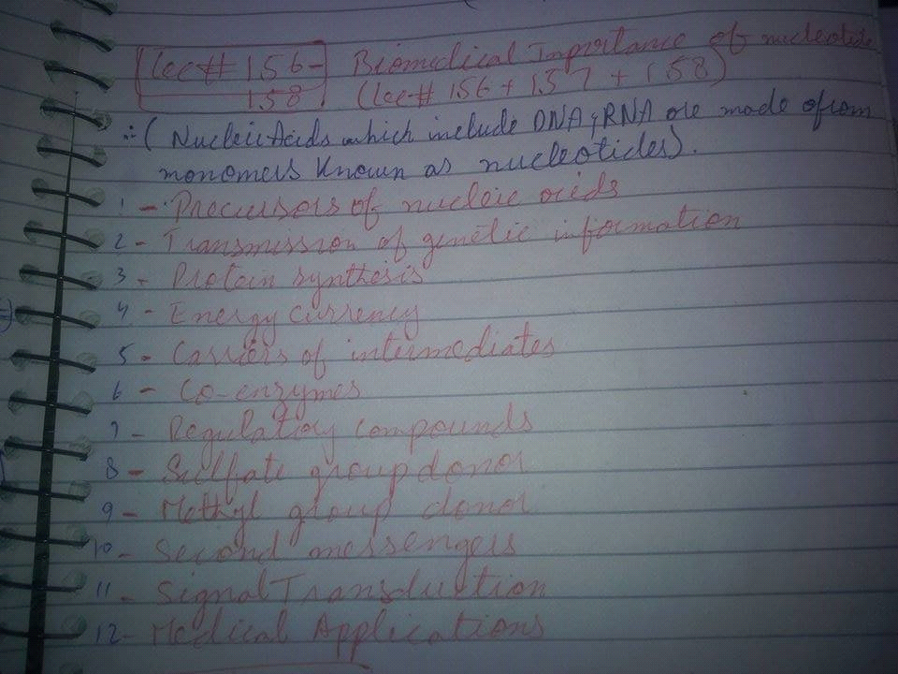

6: What is waxes?? explain in detail?
Waxes are a diverse class of organic compounds that are hydrophobic, malleable solids near ambient temperatures. They include higher alkanes and lipids, typically with melting points above about 40 °C (104 °F), melting to give low viscosity liquids. Waxes are insoluble in water but soluble in organic, nonpolar solvents. Natural waxes of different types are produced by plants and animals and occur in petroleum.
Animal waxes[edit]
The most commonly known animal wax is beeswax, but other insects secrete (release) waxes. A major component of the beeswax used in constructing honeycombs is the ester myricyl palmitate which is an ester of triacontanol and palmitic acid. Its melting point is 62-65 °C. Spermaceti occurs in large amounts in the head oil of the sperm whale. One of its main constituents is cetyl palmitate, another ester of a fatty acid and a fatty alcohol. Lanolin is a wax obtained from wool, consisting of esters of sterols.[1]

Plant waxes[edit]
Plants secrete waxes into and on the surface of their cuticles as a way to control evaporation, wettability and hydration.[3] The epicuticular waxes of plants are mixtures of substituted long-chain aliphatic hydrocarbons, containing alkanes, alkyl esters, fatty acids, primary and secondary alcohols, diols, ketones, aldehydes.[2] From the commercial perspective, the most important plant wax is carnauba wax, a hard wax obtained from the Brazilian palm Copernicia prunifera. Containing the ester myricyl cerotate, it has many applications, such as confectionery and other food coatings, car and furniture polish, floss coating, surfboard wax and other uses. Other more specialized vegetable waxes include candelilla wax and ouricury wax.
7: what is enzyme exp
a substance produced by a living organism which acts as a catalyst to bring about a specific biochemical reaction.Examples are lactase, alcohol dehydrogenase and DNA polymerase.
1)What is ranicidity?what are the factors that effect the rancidity of fats?5 marks
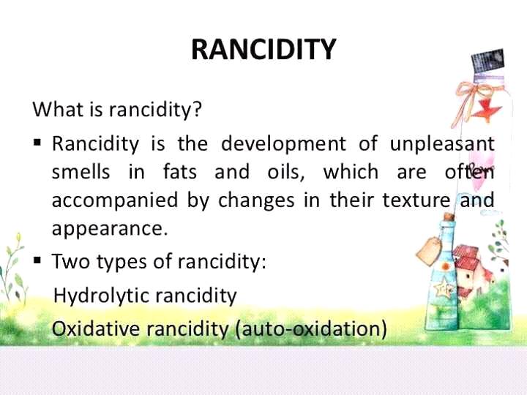

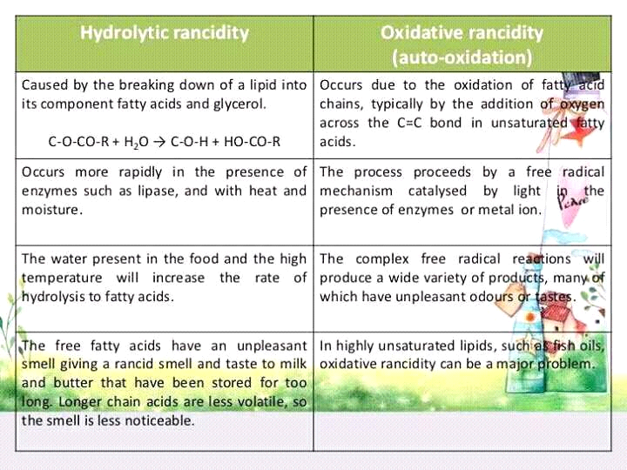

2)Primary structure of DNA?5marks

DNA Primary Structure
•The primary structure of a nucleic acid is its
•covalent structure and
•nucleotide sequence

The back bone of the primary structure is the linear strand made by sugar phosphate residues, linked together, while the bases project laterally.
•This way a long, un-branched chain is formed
Primary structureis a huge linearpolymer of dNTPsthat are joined toeach other by 5’-3’ PDE bonds

•Purines and pyrimidinesproject laterally from the backbone and forms a variable part.
•The variable part is concerned with the expression of genetic information.

3)What are sterols?give 1 example of sterol present in animal tissue?3 marks
any of a group of naturally occurring unsaturated steroid alcohols, typically waxy solids.
Sterols, also known as steroid alcohols, are a subgroup of the steroids and an important class of organic molecules. They occur naturally in plants, animals, and fungi, with the most familiar type of animal sterol being cholesterol
Example:cholrestrol in animal.
4)Differentiate b/w the structure of thymine and uracil?2marks
The only difference between thymine and uracil is a methyl group - thymine has it, uracil doesn't.
5)Write 3 functional group or purine and pyrimidine?3 marks
nitro group
Exocyclic amino group
Or 3rd ha carbonyl group
6)What are waxes?give their properties and also explain its types?10 marks
Waxes is a general term used to refer to the mixture of long-chain apolar lipids forming a protective coating (cutin in the cuticle) on plant leaves and fruits but also in animals (wax of honeybee, cuticular lipids of insects, spermaceti of the sperm whale, skin lipids, uropygial glands of birds, depot fat of ...
property:They include higher alkanes and lipids,
typically with melting points above about 40 °C (104 °F),
melting to give low viscosity liquids.
Waxes are insoluble in water but soluble in organic, nonpolar solvents.
http://www.depil-ok.com/index.php/en/hair-removal/types-of-waxes-and-its-compositions check this for types/
7)What are enzymes?explain the types of enzymes?10 marks
are macromolecular biological catalysts. Enzymes accelerate, or catalyze, chemical reactions. The molecules at the beginning of the process upon which enzymes may act are called substrates and the enzyme converts these into different molecules, called products.
There are six main groups of enzymes - hydrolases, isomerases, ligases, lyases, oxidoreductases, and transferases. The enzymes involved in food decomposition and in the digestive process are hydrolases. They break down proteins (proteases), carbohydrates (carbohydrases or amylases), and fats (lipases).
Keratin kis main presrnt hy (hoof hair nails)
Palmitic acid main carbons kitny hty hyn (16)
type of Polysachride
starch, glycogen, cellulose and chitin. The function of starch and glycogen are to store energy with cells within a body. Cellulose and chitin are designed to protect cells.

At 25°C kw value kia hti hy
1×10^14 or 1×10^-7
from where bile discharge and store?
After eating, this stored bile is discharged into the duodenum. The composition of gallbladder bile is 97% water, 0.7% bile salts, 0.2% bilirubin, 0.51% fats (cholesterol, fatty acids and lecithin), and 200 meq/l inorganic salts.

Rhinocerous k horn kis sw bny hty hyn ?
The horns are made of keratin, the same type of protein that makes up hair
what factors affect enzyme kinetics
Several factors affect the rate at which enzymatic reactions proceed - temperature, pH, enzyme concentration, substrate concentration, and the presence of any inhibitors or activators.
Michelus mentn eq kis liye hti hy
Vmax is equal to the product of the catalyst rate constant (kcat) and the concentration of the enzyme. The Michaelis-Menten equation can then be rewritten as V= Kcat [Enzyme] [S] / (Km + [S]). Kcat is equal to K2, and it measures the number of substrate molecules "turned over" by enzyme per second.
Cmptetetive non competitive inhibitor
Competitive inhibition is a form of enzyme inhibition where binding of the inhibitor to the active site on the enzyme prevents binding of the substrate and vice versa. Most competitive inhibitors function by binding reversibly to the active site of the enzyme.
Non-competitive inhibition is a type of enzyme inhibition where the inhibitor reduces the activity of the enzyme and binds equally well to the enzyme whether or not it has already bound the substrate.
Two functions of linolin
linlin calld wool wax .Wool wax is a naturally occurring substance, designed by nature to soften both skin and wool fibres, and to protect them against adverse outside weather conditions.
Enzymes? Classification with examples
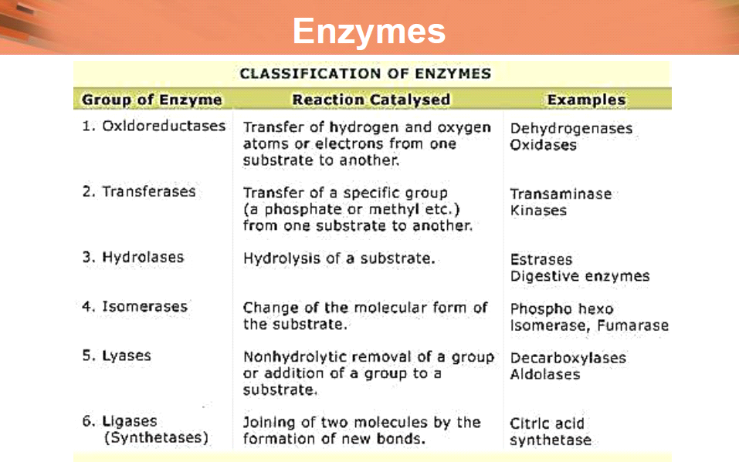

Give example of condensation - 2
Examples of Condensation: 1. Having a cold soda on a hot day, the can "sweats." Water molecules in the air as a vapor hit the colder surface of the can and turn into liquid water.
Two proprties of glyceroltrinitrate - 2
It is soluble 1 in 800 of water and 1 in 4 of ethanol. It is miscible with acetone, glacial acetic acid, ethyl acetate, benzene, pyridine, chloroform, chloroform and ether.
It is sparingly soluble in petroleum ether, liquid petrolatum and glycerol.
Bees wax and spermeti - 10
Beeswax (Cera alba) is a natural wax produced by honey bees of the genus Apis. The wax is formed into "scales" by eight wax-producing glands in the abdominal segments of worker bees, who discard it in or at the hive. The hive workers collect and use it to form cells for honey-storage and larval and pupal protection within the beehive. Chemically, beeswax consists mainly of esters of fatty acids and various long-chain alcohols.
Beeswax has long-standing applications in human food and flavoring. For example, it is used as a glazing agent, a sweetener, or as a light/heat source. It is edible, in the sense of having similar negligible toxicity to plant waxes, and is approved for food use in most countries and the European Union under the E number E901. However, the wax monoesters in beeswax are poorly hydrolysed in the guts of humans and other mammals, so they have insignificant nutritional value.[1] Some birds, such as honeyguides, can digest beeswax. Beeswax is the main diet of Wax moth larvae.
Spermaceti (from Latin sperma meaning "semen", and ceti, the genitive form of "whale"[1]) is a waxy substance found in the head cavities of the sperm whale (and, in smaller quantities, in the oils of other whales). Spermaceti is created in the spermaceti organ inside the whale's head
Two theories for the spermaceti organ's biological function suggest it either controls buoyancy, or acts as a focusing apparatus for the whale's sense of echolocation. There has been concrete evidence to support both theories. The buoyancy theory holds that the sperm whale is capable of heating the spermaceti, lowering its density and thus allowing the whale to float; in order for the whale to sink down again, it must take water into its blowhole which cools the spermaceti into a denser solid. This claim, however, has been called into question by recent research which indicates a lack of biological structures to support this heat exchange, as well as the fact that the change in density is too small to be meaningful until the organ grows to huge size.[2]
Explain numbring of carbon atoms in nitroginus bases. - 2/No of carbon atoms and nitrogens in nucleotide
Purines contain two rings in structure and both ring are attached to each other. One ring is 6 conrnered and one is 5 cornered ring. when these both ringes attaches thne the poition of nitrogen on ring is position 1,3,7, and 9 while carbon have position 2 4 5 6 and 8
While in pyrimidine bases have 6 cornered ring and the postion of nitrogen on ring is 1 and 3 while position of carbon is 2 4 5 and 6.
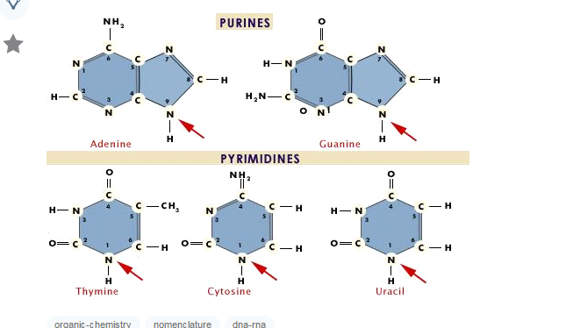

Write five Properties of nitrogenous bases. - 5
Nucleotides are relatively complex molecules that consist of three fundamental components: a nitrogenous base, a sugar and one (or more) phosphate groups.
A wide range of nucleotides are required for specific cellular functions, such as information transfer or signalling processes within and between cells; minor forms of nucleotides are particularly prevalent within stable RNAs (rRNA and tRNA) or as unwanted by‐products of reactions occurring within the cell.
Nucleotides exist as monomers and in polymeric forms, called nucleic acids, and there are two closely related types: ribonucleotides are present in ribonucleic acid (RNA) and deoxyribonucleotides, which are synthesised by the reduction of ribonucleotides, are present in deoxyribonucleic acid (DNA).
Nucleotides are in constant flux between their free and polymeric states, and their levels are regulated efficiently because cells have small pools of free nucleotides; an exception to this is adenosine‐5′‐triphosphate (ATP), which is more abundant due to its role as the universal currency of energy in biological systems, which arises from its high potential for phosphate transfer to other molecules.
The covalent structure of nucleotides are relatively stable, but they are involved in a variety of chemical reactions within the cell and can be broken down by acid‐catalysed hydrolysis, with purine nucleotides generally being more easily hydrolysed than pyrimidine nucleotides.

Name the pentose sugars present in nucleotide also write down chrechters
Ribose and Deoxyribose. The 5-carbon sugars ribose and deoxyribose are important components of nucleotides, and are found in RNA and DNA,

In chemistry, a glycosidic bond or glycosidic linkage is a type of covalent bond that joins a carbohydrate (sugar) molecule to another group, which may or may not be another carbohydrate.
Cyclic guanosine monophosphate (cGMP) is a cyclic nucleotide derived from guanosine triphosphate (GTP). cGMP acts as a second messenger much like cyclic AMP. Its most likely mechanism of action is activation of intracellular protein kinases in response to the binding of membrane-impermeable peptide hormones to the external cell surface
.[1]Example of unnatuarl Pyrimidin

